Missionary Newsletter from East Angola Annual Conference
Missionary: Kutela Katembo Dieudonne
Mission: UMC Quessua Agriculture Center

E-mail:kkatembo@umcmission.org
Tel: (00244) 925213393

February 2024

Dear Faithful brothers and sisters in Christ, I greet you in the name of our Savior and Lord Jesus Christ. I thank God for the past year and the privilege of life and health to start this new one. I hope that you and your loved ones had a blessed Christmas and are now also enjoying the beginning of a new year.
By the grace of God, my family and I are doing well and I am thankful to God for keeping me strong and committed to his mission. I believe that together we are once again going to lift up God’s mission by serving with the needy community in the East Angola Conference.

Poultry project

The construction of the chicken coop is complete despite challenges during the construction period brought on by heavy winds and rain. I am glad that is behind us and we can now complete equipping the coop, including bringing in the chicks and chickens.
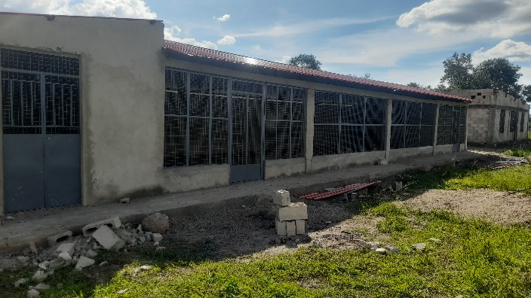
Finished chicken coop

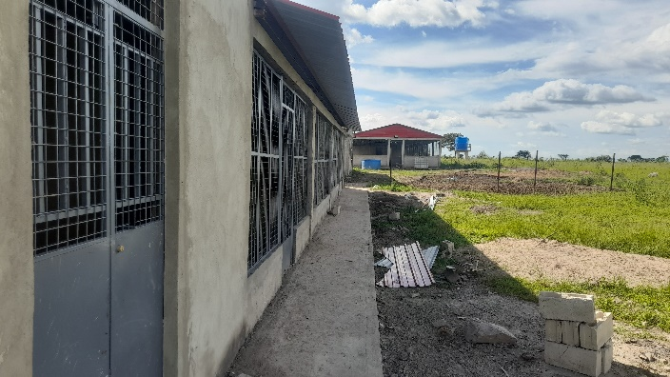

We have started with 300 chicks and 200 hundred laying hens. We expect the chicks to start laying eggs in six months, further increasing our egg supply.

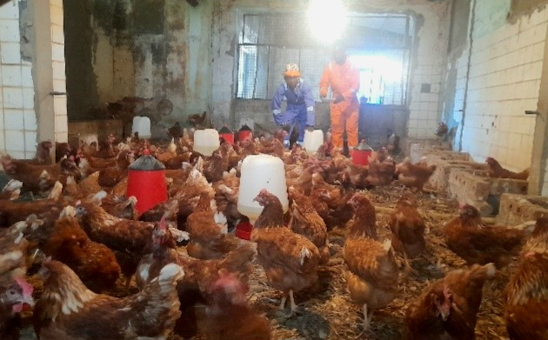 Layer hens

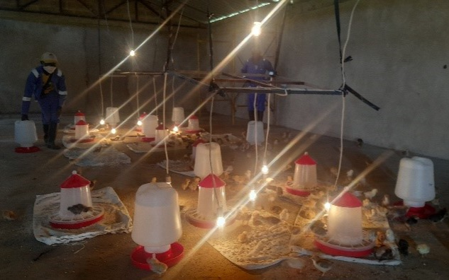
Chicks in the chicken coop

Intern student at Quessua farm.

This year we received a student from Africa University in Zimbabwe (a related united Methodist institution), who came to do his 10-month internship with us at the farm. I am very excited to have 26-year-old Cristiano Ndalaie at the farm with us. He chose to come back to his home country to serve and learn at the Quessua Agriculture center. From the start Cristiano integrated well with our farm staff and works well alongside of them. I believe that by the time he returns to finish his final school year, he will have learned a lot.

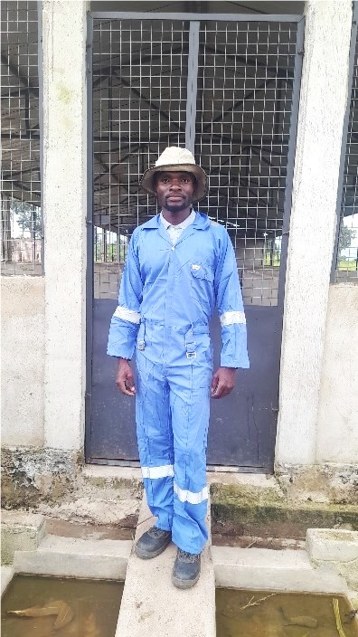

Intern Cristiano

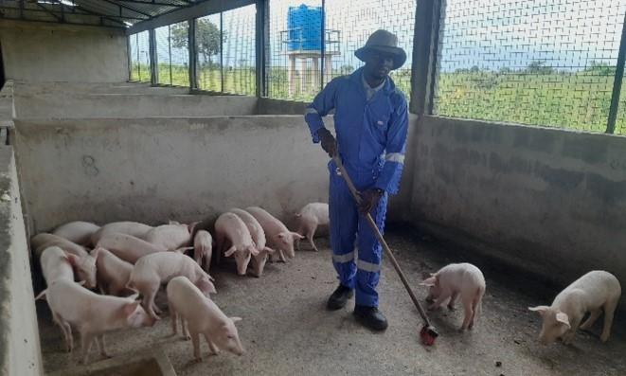

Cristiano working in the piggery

Quessua Community support

People from the village community we serve visit us from time to time to thank the Quessua Agriculture program for its continuous support with seeds, tools, and training. As we are in the second phase of the rainy season, we are going to share bean seeds with the community for the second planting season.

After these second rains, by early April, we will start preparing seed beds with the community. This will provide them with seedlings for their own dry season gardens.
We thank you for your gifts of vegetables seeds that help improve the livelihood of our needy community.

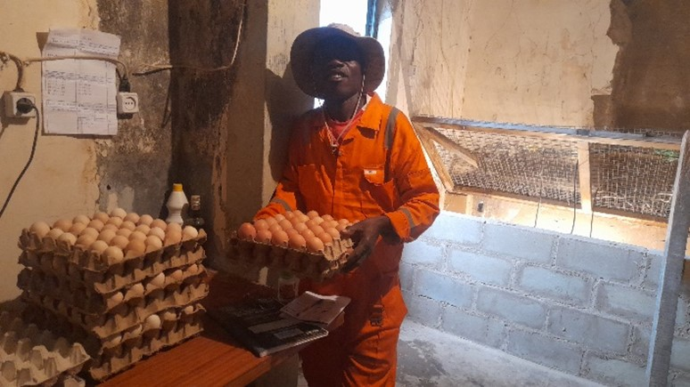

Egg collection by farm worker Nando Fernandez

ADVANCE SPECIAL NUMBERS:
Partner with me,
I am very grateful for the support you continue to give to our project and to myself the missionary. There are two ways to make your contributions:

-Advance # 3022272(Quessua Farm Project support)
-Advance#3022031(KUTELA Salary support)

1. Utilizing the Global Ministries website: www.umcmission.org. To donate for my project and salary support, at the bottom of the page, click on “Missionaries”, scroll to my name on the page and my profile will appear. At the bottom of my profile is a link to make an online donation.

2. Mail a check. Make your check payable to ADVANCE GCFA. Write “For support of Missionary Kutela Katembo.

Advance # 3022272 or # 3022031”Send your check to ADVANCE-GCFA, 458 Ponce de Leon Ave.N.E; Atlanta, GA. 303083. Through your Conference office indicating “for Kutela Katembo”,

STAY IN TOUCH!
I thank you for your support and friendship. Please stay in touch with the Quessua
Agriculture Center Team on the following platforms:
Email: kkatembo@umcmissioFacebook: @QuessuaAgCenter

God Bless you! – Kutela

